Town of Carrboro Language Access Plan Executive Summary
The Town of Carrboro’s language access plan provides a roadmap for guaranteeing community members’ right to access services and information in their preferred languages. It describes the Town’s commitment to and instructions for providing access to quality language services free of charge. These services include interpretation, translation, and/or direct communication with bilingual Town staff.
The plan, which Carrboro’s Town Council unanimously approved in April 2024, grew out of a yearlong collaboration between Town staff, members of the Refugee Community Partnership, and the Building Integrated Communities (BIC) program of the Institute for the Study of the Americas at UNC-Chapel Hill. The language access plan is comprehensive, meaning it applies to all Town departments, and it includes policies, procedures, and a plan implementation timeline to facilitate communications and community engagement in languages other than English. The plan is designed to be a living document, one that the Town and community members regularly revisit to reflect changes in local demographics, resources, and community and staff priorities.
Building Integrated Communities Partnership
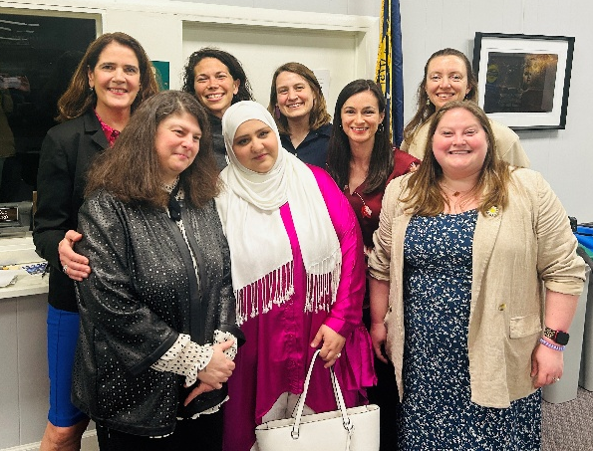
Between April 2023 and April 2024, staff from the Town of Carrboro, the Refugee Community Partnership, and the BIC initiative at UNC-Chapel Hill met monthly to gather data and identify community priorities for language services in Carrboro. The team relied on data from the U.S. Census Bureau, the Orange County Health Department, Chapel Hill-Carrboro City Schools, and members of the Refugee Community Partnership to determine “community languages”, which are the languages Carrboro residents most speak (other than English), and have higher proportions of speakers who rate their ability to speak English as “less than very well.” While the language access plan is designed to aid Town staff in securing services for any language, identifying community languages helps Town staff identify which languages may most often be requested for interpretation or translation. In this plan, the Town of Carrboro identified its community languages as Spanish, Chinese, Korean, Karen, Burmese, and Arabic.
By early 2024, the team drafted a language access plan based on review of these data as well as responses from a survey on Town staff’s capacity and resources to provide language services. The team committed to revisiting demographic data, input from community members, and surveys of Town staff’s capacity to provide language services regularly to ensure that the language access plan addresses the most important priorities and needs in the future.
Town of Carrboro, Refugee Community Partnership, and BIC staff after the Language Access Plan was passed by Town Council.
Language Access Policies and Procedures
Policies refer to what the Town of Carrboro will do to guarantee access to language services. Procedures refer to how Town staff and leadership will put policies into action, and they mostly take the form of guidance for Town staff and instructions for the public to request and give feedback on language services. The language access plan includes a general statement of policy, which states the Town’s commitment to providing timely meaningful access to all its programs, resources, and services for any individuals who prefer to speak a language other than English. It also states that staff will inform community members of their right to free language services and secure these services when they are needed.
The plan includes more detailed policies organized around the following areas:
- Policies for interpretation and translation, including the Town’s commitment to not rely on minors or family members of residents for interpretation or translation.
- Policies for providing public notice of availability of interpretation and translation services.
- Policies for staff training on language access policies and procedures.
- Policies for assessment of language access services, including evaluating their effectiveness and seeking feedback from Town staff and community members.
- Policies for language access monitoring, reporting, and compliance.
Procedures are organized in the following categories and will be updated as the Town assesses the effectiveness of and commits resources to language access:
- Procedures for determining the need for language assistance, which can be determined in interactions with community members.
- Procedures for requesting translation and interpretation services for both community members and Town staff.
- Procedures for identifying vital documents and information, which helps Town staff determine which of the documents they regularly use should be considered priority for translation.
- Procedures for the notice of availability of language services.
- Procedures for staff training and orientation on the language access plan.
- Procedures for monitoring and updating the language access plan.
- Procedures for filing and resolving complaints about language services.

Implementation Goals and Timeline
Following the plan’s adoption, the implementation plan outlines priorities and guidance for Town staff who coordinate and create new systems for language services. The goals are grouped into the following categories:
- Increasing availability of written translations of vital documents, starting with Spanish. The team decided to prioritize Spanish as a default language in documents it translates because it is the most commonly-spoken language other than English in Carrboro and is the language that Town staff most commonly encounter (other than English).
- Developing an internal language access committee to put language access structures in place. The Town’s Communication team functions as the inaugural committee.
- Increasing availability of interpretation at public events and meetings.
- Strengthening recruitment, support, and management of multilingual staff members to provide quality in-person language services.
The Town has created a web page that provides updates on new language access services, translations of vital documents, and informing community members how to request services like translation and interpretation.

